# Christmas in Portland

Places mentioned in this post:

Idaho Falls, Idaho

Meridian, Idaho

Pendleton, Oregon

Lake Oswego, Oregon

Two nights before I left on my Christmas trip to Portland, I squeezed in a visit to the Idaho Falls Temple. The Nativity scene and the red floral accessories in front were especially beautiful.

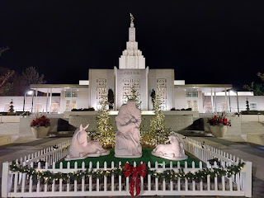

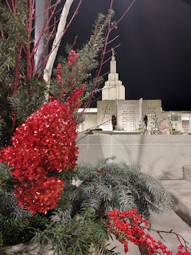

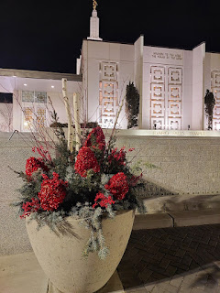

The next evening, I brought my niece, Mari, with me to our Ward Christmas Party. The food wasn't that great, but the decorations were fun and the sing-along was even more fun! At one point, we all participated in singing The 12 Days of Christmas, with a different assignment for each table. My table was given the verse "12 drummers drumming", and when it was finally our turn, we drummed on the table with our hands while we shouted out the words.

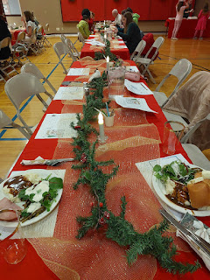

Mari has a new kitten, named Angel. She has a remarkable ability to jump up way higher than you would think she could at her age . . .

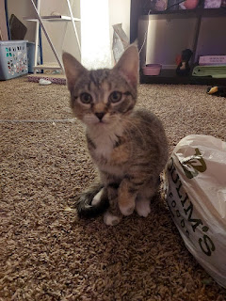

We'll see if she lives up to her name, ha ha . . .

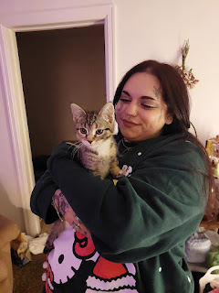

Friday, December 13th:

I drove across the state in (my son-in-law) Weston's car, a 2010 Hyundai Elantra. It's a quirky car because of its age, and it also happens to be a stick shift. One of the quirky issues is that I can't fold down the driver-side visor. I have sunglasses that I always wear, but sometimes the sun can be pretty intense and a visor would be helpful. I ended up rigging my own workaround: a piece of cardboard for a visor. I can slide it forward if I need it, or retract it, too.

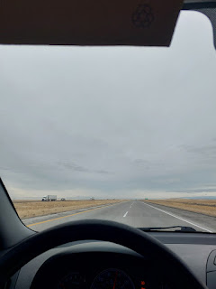

It worked great on my drive.

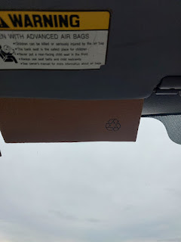

The reason I was driving this particular car is because Benson had swapped it with my Ford earlier this fall, and it seemed convenient for me to just swap it back as I drove west on this trip, since he lives right on the way. I had to figure out how and when to do the swap, though, because Benson was out of town all week. He had to fly down to Las Vegas to be a potential witness in a court martial regarding an incident that happened in Italy 3 years ago. A co-worker had been accused of sexual assault and the girl had told Benson about the incident. But when Benson was sworn in to testify, his two minutes of fame turned out to be struck down as hear-say and then he was all done. So he spent a week away from home, work, and his doggy, for two minutes of nothing . . .

Anyway, I made plans to spend the night with my friends, Jeff and Sherry Haines, in Meridian while I waited for Benson to fly back into Boise the following day. These are friends that I met in Italy as they served as military relations missionaries in our Vicenza Ward. Sherry and I share a special kinship that feels like we were meant to be sisters. She is 10 years older than I am.

On Friday night, they had their own Ward Christmas Party, but it was in the form of a Night in Bethlehem. I've always wanted to go to something like this, but have never been in the right place at the right time before. I brought my Moroccan tunic with me to wear, the one that Abdel helped me pick out in the Souk Market of Agadir last May.

The invitation (or "decree") for the evening was posted on Sherry's fridge . . .  (click photo for more details)

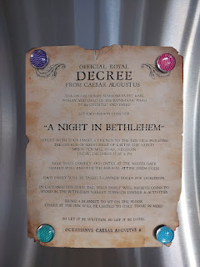

The guest room where I stayed twice with the Haines . . . both on my way to and from Portland.

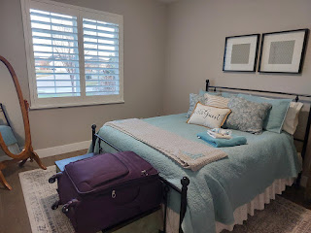

Ready to go to Bethlehem . . .

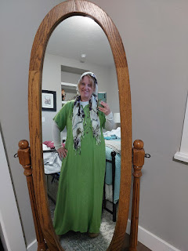

Sherry and her husband, Jeff brought some canned goods as our "tax", and then Sherry and I helped with some setup and prep before the event began. We assembled 200 veggie cups (with a carrot, a celery stick, one slice each of red/orange/yellow bell pepper, and a cucumber stick. We did most of the cutting and slicing prior to placing them into the cups. Then we helped assemble 200 fruit cups with both red and green grapes. Everything was assembled onto large trays and then brought out to our "booth" in the Bethlehem market, located in the church gymnasium.

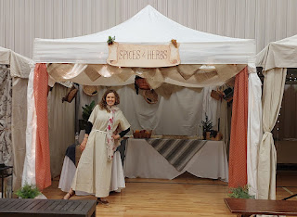

Ready for our little "market" stand to open . . .

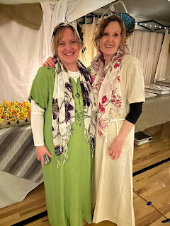

Video of the fruits and veggies in our booth, along with some tasty hummus that someone else made: (13 seconds)

https://photos.app.goo.gl/whbqvZux4nNHjVTz5

I took a few photos before the guests arrived . . . everything was beautiful and peaceful and still . . .

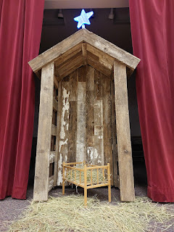

A carpentry shop was set up where the children could: 1) collect a handmade wooden ornament to hang on their Christmas tree, and 2) decorate their own wooden ornament with Christmas-y stamps.

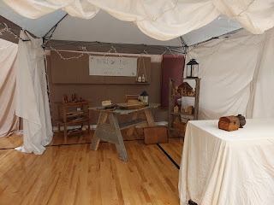

This booth had the most amazing sourdough bread - Sherry told me that her ward has a 40-year old sourdough starter that has been passed around and shared.

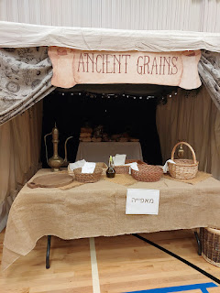

In the booth next to us was the "main dish" area - the Butchery, consisting of rice, loads of chicken that had been chopped up nice and small, lettuce, tzatziki sauce, and hummus. Slices of cheeses and salami and crackers were also available for "purchase".

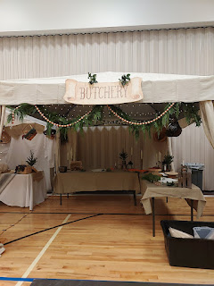

The bakery was soon full of colorful cookies and baked goods for dessert . . .

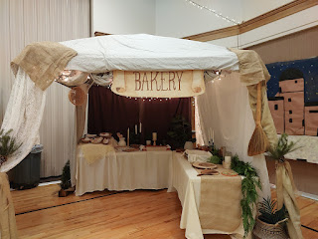

The empty gym before everyone arrived . . .

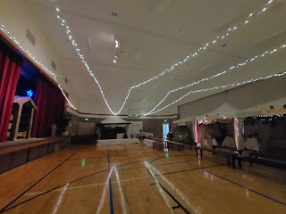

The "water well" was filled with water bottles . . .

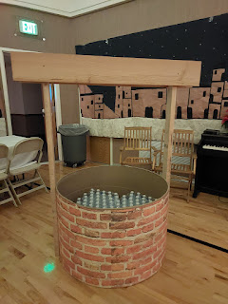

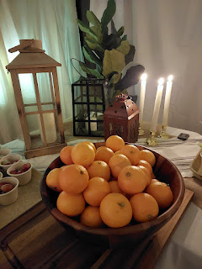

This was the best sourdough I've ever had in my ENTIRE LIFE (the lighter colored bread below) . . .

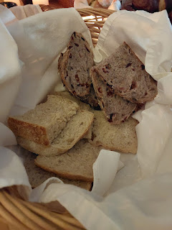

Meats and cheeses in the Butchery shop . . .

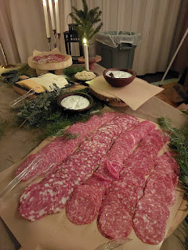

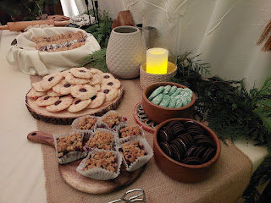

Above and below - some of the delicious goodies from the Bakery shop . . .

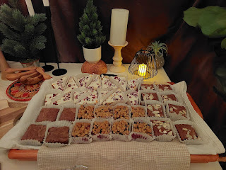

A young boy was dressed up as a Roman soldier . . .

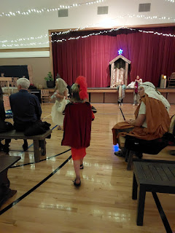

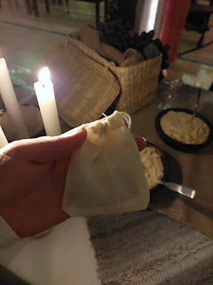

Above and below: the pouch of coins we received after donating our canned goods . . .

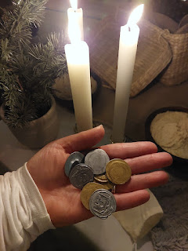

A cute mom and her kids that came through our booth . . .

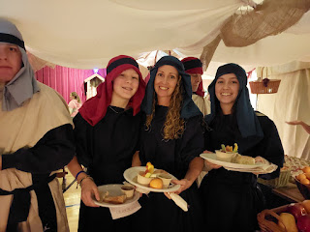

As you went from booth to booth, you would pay for your selections with one coin at each place. We had been encouraged to bring a blanket to sit on, as the tables and benches were reserved for those who couldn't sit easily on the floor. A few ladies came to swap us out at one point so that we could get our own dinners and enjoy the rest of the evening.

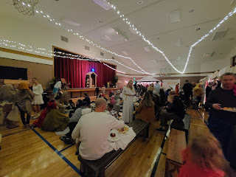

On my plate I had a veggie cup with hummus, a clementine, the amazing sourdough bread, some salami and cheese, and a little bit of the rice/chicken/salad with tzatziki sauce, plus a couple of cookies for dessert.

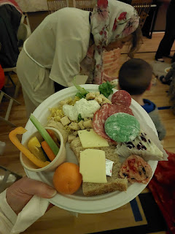

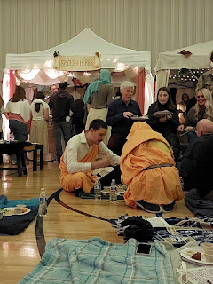

We happened to find a spot right next to the stage, where we soon had front row seats for the presentation of the Nativity story.

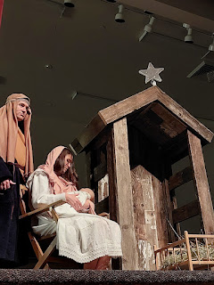

Video of the most unassuming man singing Oh Holy Night in a beautiful voice: (1 min, 28 seconds)

https://photos.app.goo.gl/JtrfYJLZdCMNNP6z8

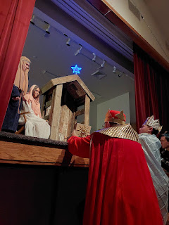

They all did such a great job and I was very impressed by how many talented singers they had in just one ward!!

Here is a closeup of the carpentry shop as the evening was winding down . . .

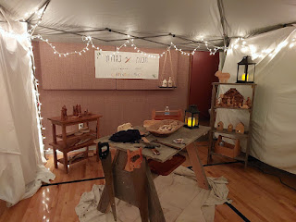

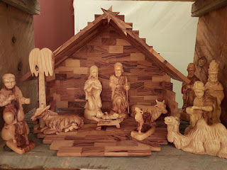

They also had a station where you could write a little note to the missionaries who were from this ward but who were currently serving all around the world . . .



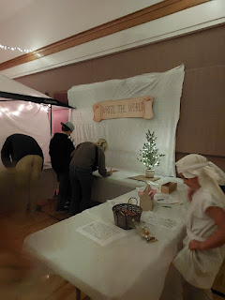

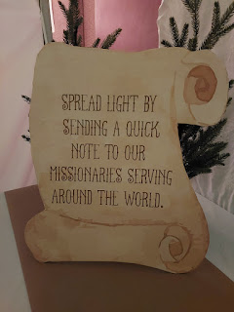

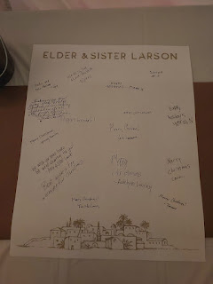

After we helped clean up and put everything away, we drove back to Jeff and Sherry's house and changed into walking attire for a short stroll around the neighborhood. I wanted to see all the Christmas lights that were set up at nearly every single house. It was crisp and cold, but it felt really good to get some fresh air before bed.

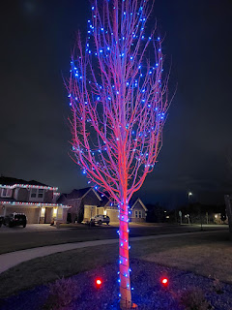

Saturday, December 14th:

I accompanied Jeff and Sherry to the ribbon-cutting of the new Light the World vending machines in Meridian. These vending machines are set up for roughly 2 weeks during the Christmas season in a handful of places around the world (London, Washington DC, Salt Lake City, etc.). They are sponsored by The Church of Jesus Christ of Latter-day Saints and they offer several items to purchase (or sponsor) for people in need, both foreign and domestic. There are typically a few local non-profit charities that are represented, as well as some regional and global charities.

In December of 2023, these giving machines raised a record $10.4 million through approximately 600,000 donations across 61 locations in seven countries. Items typically include meals, clothing, medical care, livestock, newborn resuscitation kits, school supplies, feminine hygiene products, etc.

There aren't any public totals just yet of how much has been raised this Christmas season, but the expectation is that last year's record will be surpassed because this year there were over 100 cities across 13 countries that have participated (including new locations in Africa and Asia).

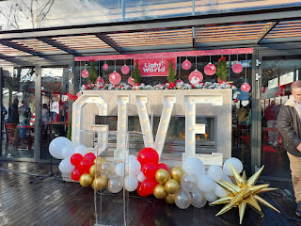

There is a huge outdoor shopping mall of sorts in Meridian called The Village, with shops and restaurants that seem to go on for days . . . The CEO of The Village is a member of our church, and he helped facilitate the location of the Giving Machines to be right next to a popular coffee shop and cafe, as well as a huge movie theater, outdoor ponds, and the line for families to get in if they want to visit Santa Claus! A great place to Light the World, if you ask me.

Jeff and Sherry had signed up as volunteers to help with the vending machines during the busy holiday season, so they wanted to be at the ribbon-cutting ceremony to check things out. If the line ends up being long for those who come to make a purchase, which many times it is, volunteers can hand out a "menu" so patrons can make their decisions ahead of time on what they would like to purchase.

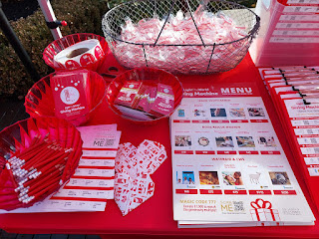

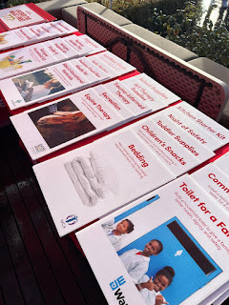

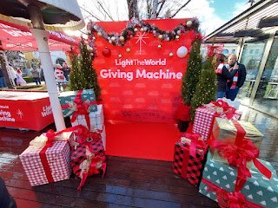

Prior to the ribbon-cutting, the vending machines were all covered up with wrapping paper and bows.

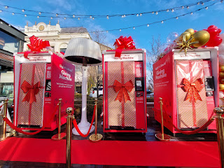

Several people spoke briefly during the ceremony, including this husband and wife from Meridian. I don't recall his name, but he is a local doctor who has made it his life's work to make sure that individuals who don't have insurance - and can't afford to get any - can still access quality healthcare.

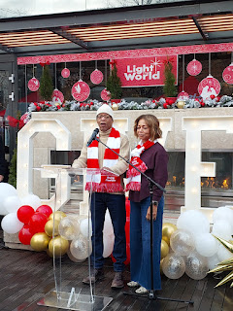

The last speaker was Elder Stephen Larson, an Area Authority for our church who also lives in Meridian and attends Jeff and Sherry's ward.

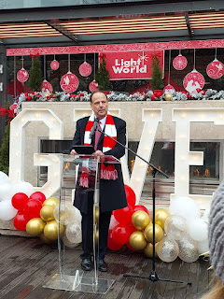

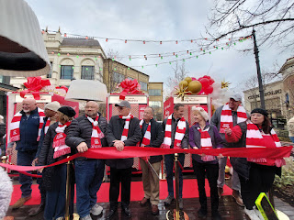

Again, we just happened to have a great standing location next to all the festivities, including the actual ribbon cutting!

Video of the ribbon being cut by the mayor of Meridian: (7 seconds)

https://photos.app.goo.gl/81dchpiwufuFokQS7

Next, the CEO of The Village was invited to make the first purchase. But first he had to tear off the wrapping paper with everyone chanting 3-2-1 . . .

Video here: (9 seconds)

https://photos.app.goo.gl/toWUPZEmzFJk5JZf9

He entered the magic code of 777 to purchase EVERY SINGLE ITEM IN THE WHOLE VENDING MACHINE!! It totaled something like $1900 dollars when the machine finished dropping each item into the tray down below.

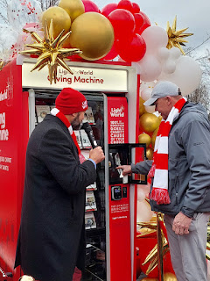

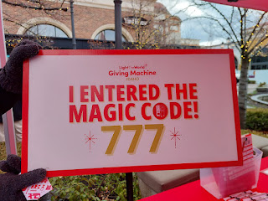

As people got into lines to buy something, musical numbers were performed, including a song by these darling children. Later on, there was a bell choir, too.

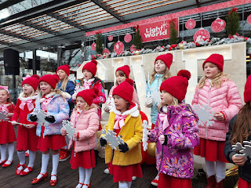

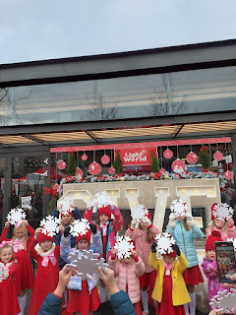

We didn't want to lose our place in line, since we ended up being at the front, but I had left my purse and wallet in their car. So Sherry came with me up to the vending machine so we could use her credit card, and then I just paid her back on Venmo. It was difficult to decide what to purchase, but super fun at the same time!

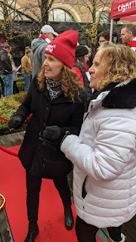

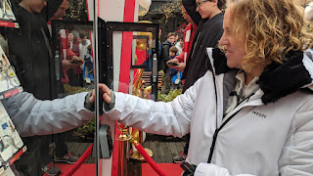

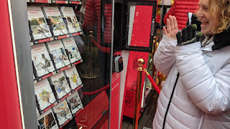

I chose to purchase a garden plot, equine therapy (I have a passion for horses and the world of good they can do for us humans), as well as a safe birth for a mom (the fine print says that it provides a maternity ward with running water to aid in a baby's delivery).

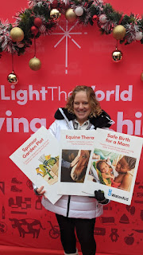

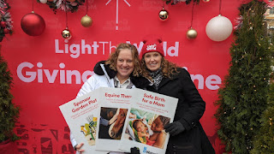

It felt so good to be able to donate these needful things to someone in need. Some of us can donate a gift of time or services, and others might choose to donate money towards those goods and/or services, which is every bit as helpful, too. :) It just depends on what stage of life you're in and what your capabilites are.

While Jeff and Sherry spent a few minutes jumping in to volunteer and practice for their future shiftwork, I wandered around the area and enjoyed the beautiful pond and sculptures. I also did some people watching, and I chatted with Scott over in Italy before he went to sleep for the night.

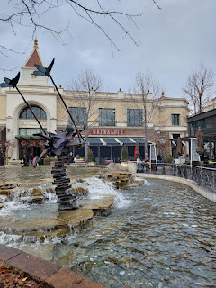

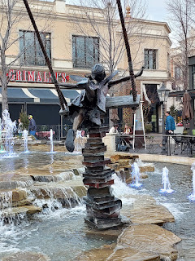

I got to see Santa's reindeer as they arrived: (9 seconds)

https://photos.app.goo.gl/vXtW8Y1SAHoTP9om6

The reindeer were ushered into a pen and then children could get their photos taken with Santa and his reindeer in the background. (10 seconds)

https://photos.app.goo.gl/X6MAi6pq48K2oWWq5

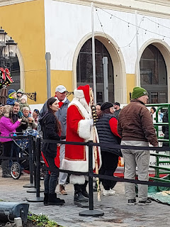

We left a few minutes later to go pick up Benson at the airport. I was intending to pick him up by myself, but Weston's Hyundai Elantra, the one I drove across the state, wouldn't start. Benson had warned me that sometimes it had done this to him, as well, and that it was likely because the brake lights in the back don't always turn off, even if you've turned the motor off.

So, Jeff and Sherry drove me to the Boise Airport to pick him up. He told us all about the trial as we drove back to Meridian. The girls that had each accused this soldier of unspeakable things all ended up retracting their stories. It appeared that they wanted to ruin his military career, which they did, but he was acquitted in the end. What a world we live in . . .

When we got back to Meridian and the dead car . . . Jeff and I pushed it backwards out of the garage, while Benson was behind the wheel. As it rolled backwards, Benson successfully popped the clutch and got it to start without needing any jumper cables. He is so cool!! I was extremely impressed. I may have done this a time or two several decades ago, but I had completely forgotten how to do it until he tried.

We loaded up the rest of my things and then we headed off to the Air Force Base in Mountain Home, which is also in the wrong direction from where I needed to eventually be. We picked up some lunch and ate it back at his house. Then I had him caravan with me to the gas station where I paid to fill up both of our gas tanks, and that's where we hugged goodbye temporarily . . . (I would see him again in 2 weeks)

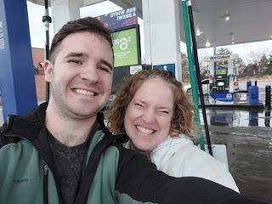

Because of the dead car battery and the extra driving in the wrong directions, I didn't get on my ACTUAL way until late afternoon. I knew the weather was going to be precarious and since I would be mostly be driving in the dark over several mountain passes, I decided to get a hotel and park it for the night in Pendleton, Oregon.

It rained nonstop the whole way, except when it was snowing. The Baker City area was a little dicey on the roads, and that's when my anxiety kicked in full-time. The windshield wipers were on high, which was making my eyes dizzy from the lack of having something to focus on for hours on end, it was dark and my headlights aren't that great, there was some occasional fog, and I had a fear that a deer would suddenly step out in front of my car since I was up in the mountains. The mountain passes, plus the change in elevation and temperatures, meant that the rain turned to slush and then to snow at the summit, then back to slush and eventually rain again as I came down the other side.

My heart rate was pretty high, and I was having trouble calming down. I started listening to Lionel Richie on Spotify, because I know most of the words to many of his songs, and I could sing as loudly as I wanted to in the car. I also said many, many silent prayers as I drove along. This worked for a while, but eventually I needed to find a place to pull over and just calm down. I used the bathroom at a gas station in Baker City and then I stood under the awning next to my car for several minutes so I could be out of the rain but also get some fresh air.

I caught up on some Snider family texts that had been going strong for the past couple of hours and then I decided to share with my parents and my siblings what I was dealing with. They promised to send some extra prayers up in my behalf, and soon I was back on the road.

As I cranked up the music again and started singing along to Lionel Richie's song (Love, Oh Love - for the 8th time), my eyes started to fill up with tears because I felt the love of my family and the strength of their prayers. It was such a beautiful feeling!

What made it even more special, is that when I did finally arrive at my hotel 1.5 hours later and I sent texts out to let everyone know that I had made it safely, here's what my I wrote, along with my Mom's response:

Me: (after Mom had asked if the roads had improved) Snow in several spots...it reminded me of the beginning of any Star Wars movie when they're hurtling through space at warp speed and all the white flecks are mesmerizing as they come straight at you. I couldn't use my high beams because it just amplified the dizzying array of snowflakes. Slush + hydroplaning too many times to count. But no more anxiety. I know it's because of your prayers. I felt them. It even made me cry. See, now I'm crying again. But happy tears.

Mom: Yuck, what a tough drive. You sure are a trooper. As soon as I finished my prayer for you, I paused to be quiet and heard the still small voice say you would be all right AND you were feeling our love right then. I was surprised. But it turned out to be true. I'm so thankful for the power of prayer and for our love! Heavenly Father was really watching over you tonight.

Wow. Just wow.

After I checked into the hotel, I went to a super cute restaurant in downtown Pendleton, called the Great Pacific. The ambiance was fantastic and the staff were so friendly and chatty. It was a great place to relax after my harrowing drive. They recommended the split pea soup, which I took them up on because it reminded me of my mom's delicious split pea soup that she made many times when I was growing up.

It was perfect and it really hit the spot. They serve lots of bagels at this restaurant, and I'm not usually a bagel eater because of the carb count, but then they told me they had a sourdough bagel! It was so good!!

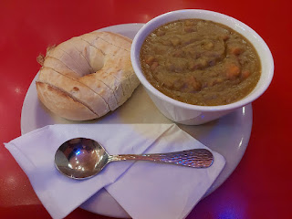

Before I left, I purchased some chocolate truffles and goodies to share with Amber and her family. I think I will make it a point to stop in Pendleton more often - mainly because of this restaurant. It's also a great stopping point to take a break on the long drive to Portland, too.

Sunday, December 15th:

I went to Sacrament meeting in Pendleton before changing into travel clothes and checking out of the hotel. The day was sunny and beautiful, such a relief after the night before. I listened to music, I listened to Harry Potter (Book 4 - the Goblet of Fire), and I chatted with both Scott and my friend, Jenn Caudle. It was a comforting mix of things to occupy my time during the last few hours of my drive. There was plenty of fresh snow on the hills and mountains along the Columbia River Gorge, which lent some additional beauty to one of my favorite drives.

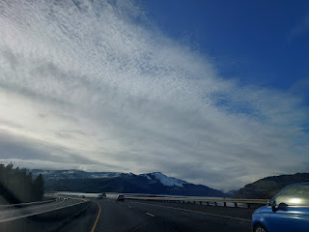

Before I knew it, my long drive was over and I was safe and sound with Weston, Amber, Abby and Gwen.

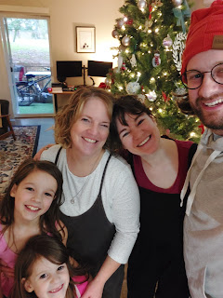

The evening was relaxing and calm, with the girls reading some books that I had brought with me, and then we played Christmas Scavenger Hunt together while Amber made dinner.

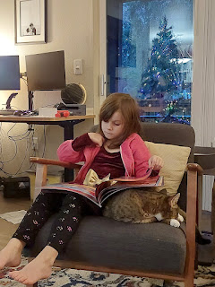

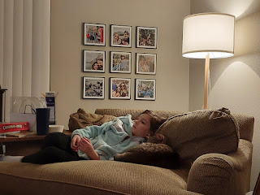

Monday, December 16th:

I walked with the girls to the bus stop, a hop-skip-and-a-jump from their apartment. This was the routine each morning for that whole week before they were on vacation for the holidays.

Amber and I ran some errands and I began plotting and figuring out how to organize their pantry, which consisted of two large hall closets. Amber had asked me ahead of time if I could help her organize a few places when I came up to visit.

After school, the girls and I played Christmasopoly - a Christmas version of Monopoly, which I had picked up at the Walmart in Pendleton. Unfortunately, I ended up in "Naughty" too many times to count, ha ha. Abby won the game quite handily - I think her strategy was to buy as many properties as she could. It wasn't exactly fair on my end, because I spent so much time (and dozens of lost turns) in "Naughty", which prevented me from ever having a chance to buy anything. But we had a great time.

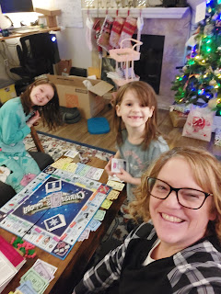

Tuesday, December 17th:

I finished organizing the pantry while the girls were in school. As soon as they got out of school, we scurried off to see Wicked at the plush movie theater in nearby Tigard. They had already seen the movie once - earlier in December, but I really wanted to see it, too. Because it's almost 3 hours long, it was especially nice to have some comfy recliner chairs to melt into.

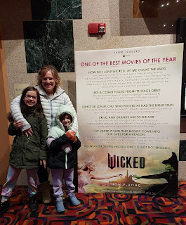

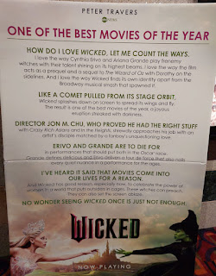

I do not have enough words of praise to share about this movie. It was incredible! I absolutely loved it. I laughed, I cried, and I couldn't even speak for several minutes afterwards. It was powerful and moving. It's a story that's been available for many years because of the Broadway version of Wicked, but I have never seen it or read about it or anything prior to this movie. It turned out to be a tale of friendship, kindness, dealing with racism and how we often judge someone based on how they look on the outside, the power of humility and forgiveness, and many many more lessons to be learned. I can't wait to see it again soon!

After a late dinner and a bath, Abby demonstrated how they just learned how to do long division at school: (2 minutes) *Note: I helped her practice her multiplication times tables for a few days after this. She especially wanted help with her 7's. :)

https://photos.app.goo.gl/HE4THJunFLvwCKNc7

Wednesday, December 18th:

Amber made the most delicious dinner!! She made turkey meatballs from scratch, with shredded zucchini and carrots in them. She also made homemade cranberry sauce and sweet potatoes for side dishes. I was in Thanksgiving Round Two Heaven!

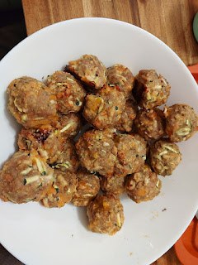

That evening, we went to a Primary activity with the children from their ward. Amber serves in the Primary presidency and had made a large poster for the foyer at church to get everyone excited ahead of this special occasion. They would be visiting the Light the World vending machines and making a large purchase as a communal service project.

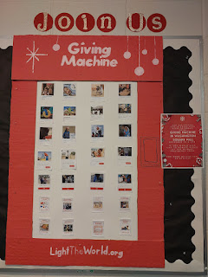

Everyone first gathered in the primary room at the church meetinghouse, where Amber prepped the children further by giving them some statistics that define your level of wealth in life. She had them hold up one finger at a time if they: had breakfast that morning, had a roof over their head at home, had clothes to wear, if their parents had a job, if they were healthy that day, etc. If you could answer yes to most of these questions, then you were in the top 1.8% in the entire world. Wow.

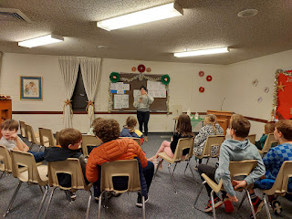

They were also shown 4 posters with groupings of potential items for purchase at the vending machine. The kids had helped to earn part of the money, but most of the money was leftover from their annual primary budget for the children in this ward (for various activities throughout the year). They had a total of $200 to spend to help others in need.

We carpooled to the nearby Washington Square Mall in Portland where the giving machines were set up inside.

Gwen dutifully posed for a picture while we waited for everyone to arrive . . .

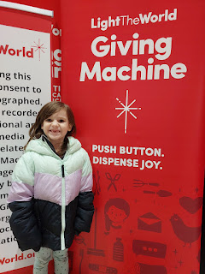

The posters were held up by some of the adult leaders, and the kids could vote for how they wanted to spend their money by standing in front of the poster they chose. The purple poster had a few items grouped together that added up to $200. There was also a green poster with different items, a blue poster, and a red poster.

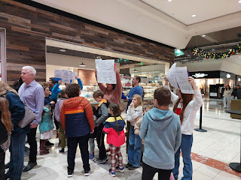

Abby was so excited to participate . . .

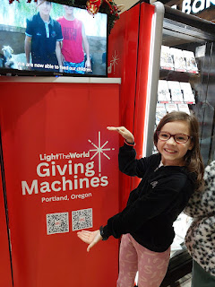

The children were given Light the World bracelets . . .

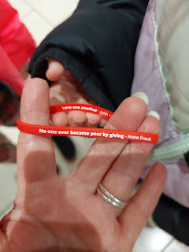

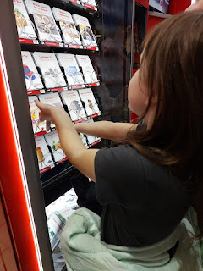

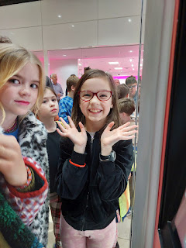

It was such a great activity for these precious children of God. They were prepped really well leading up to this evening, and it all culminated with a great visual and hand-on opportunity for them. They could literally see what was being chosen and they were a part of the democratic process, too.

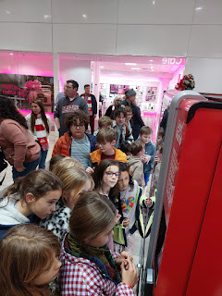

Abby's middle name is Joy . . .

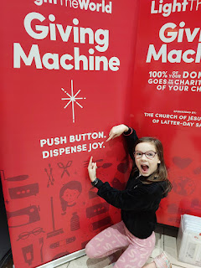

After any purchase is made from the Light the World vending machines, you can pose for a photo afterwards by holding up the poster(s) of the items you just bought. In this case, the children voted to purchase some baby bedding, 2 pairs of new shoes for foster children in need, healthy school snacks for a whole month for one disadvantaged child, 3 new books for a child in foster care, and shelter for a week.

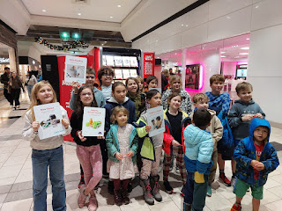

Video of what's in the Portland vending machines and some of the purchases already made: (15 seconds) *Note: Every city is different with what their local needs are and the non-profit charities being represented.

https://photos.app.goo.gl/x6Mb8DeJqCPevkfu6

Amber and Gwen also made a personal purchase of 100 polio vaccines for children under 5 years old. I shared with them how my dad's oldest sister, Carol Brown Gillette, had contracted polio and was somewhat handicapped throughout her life because of it. She never let it stop her from being kind and from being an incredible cook and baker. My love of collecting cookie cutters to this day stems from the vast collection that Aunt Carol had, and I remember how magical it was to see them as a child, and to sort through them on occasion.

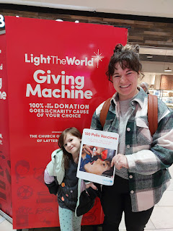

After photos were taken, we drove back to the church for some follow-up and refreshments. The primary president, Isabelle, asked the children to share their thoughts and feelings about what they had just done, and what are some additional ways we can share the Light of Christ during the Christmas season and all year long. Their answers were so sweet and pure and tender that many of the adults in the room were visibly crying.

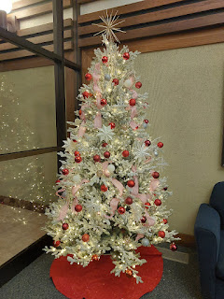

Jesus loves us all, but He especially loves the little children. They are humble and meek, pure and kind, teachable and quick to forgive. We would do well to follow their loving examples . . .

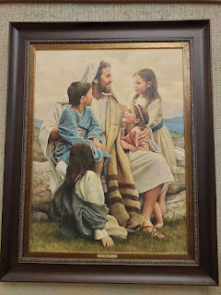

Someone told Amber that evening about a house not too far away with the most magical display of Christmas lights, so after the refreshments were devoured and cleaned up (brownies + ice cream), we drove over to see it for ourselves before bedtime.



Video of the side yard, filled to capacity: (11 seconds)

https://photos.app.goo.gl/hnPaH7Hdx2HcVGbh7

Even though their faces are shrouded in darkness, see if you can see Abby and Gwen's hilarious expressions below . . . they were excited because the sign said that Santa comes in 7 days!!

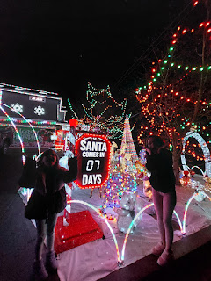

Can you even imagine where they keep all of these supplies when it's NOT Christmas season??

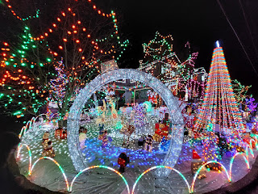

Abby, me, and Gwennie . . .

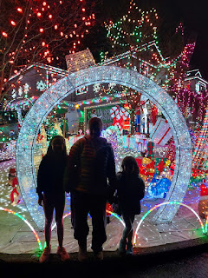

A Christmas PEACOCK . . .

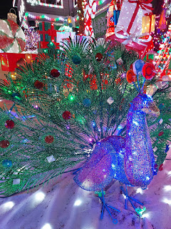

They had a sign next to the porch (which you can come up onto and see even more displays) which said: Light Up Lake Oswego Grand Champion 2022. It was super fun to get out of the car and see everything up close and on foot.

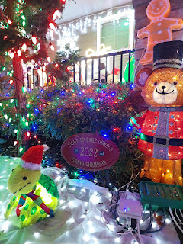

Thursday, December 19th:

After working on some additional organizing in the apartment (the bathroom closet and cupboards under the sink, plus the closet in Gwen's room), Amber and Weston left for an anniversary getaway down to Florence, Oregon. Their anniversary is on December 21st and they keep finding that it's a really difficult time to squeeze in a date or anything at all when it's so close to Christmas every single year. They are considering celebrating it on their half-anniversary, which would be on the Summer Solstice (June 21).

I was left in charge of the girls for two days and we had a great time. They each had a bag of white "slime" with supplies to make a snowman. It was hilarious to watch what they created . . .

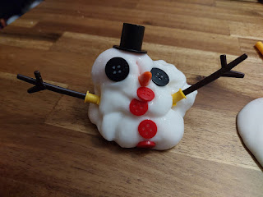

Gwen had a giggling fit as she made jokes about this little orange foam brain toy that she added into the snowman collection. It would sink into the slime and disappear, which sent her into fits of laughter, ha ha.

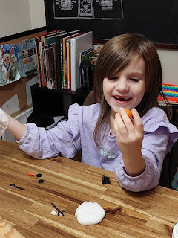

Meanwhile, Abby mastered the ability to expand her slime into a giant bubble, similar to blowing a bubble with a giant wad of bubblegum.

Watch her process here: (12 seconds)

https://photos.app.goo.gl/2B7KLbTZcDUS2xPJ9

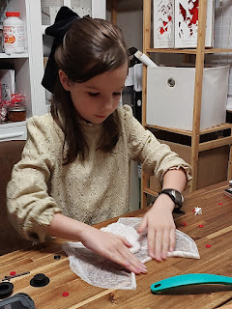

The buttons would somehow stick perfectly to the slime surface: (15 seconds)

https://photos.app.goo.gl/Ky5gkUj96F45o4tq7

Gwen giggling over some "brain jiggling": (10 seconds)

https://photos.app.goo.gl/V6kgd59qLtVcxkJZ6

Someone in their ward (who wished to remain anonymous) would knock on the door every evening and leave a treat on the doorstep, part of The Twelve Days of Christmas. They were very clever as they crafted small poems to accompany whatever item(s) they were dropping off.

For the night of "Seven Swans a Swimming" - this is what they wrote . . .

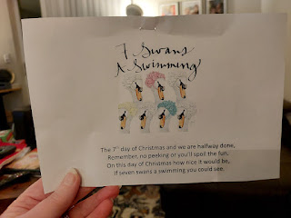

And this is what they brought . . .

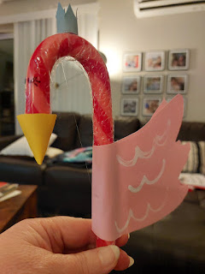

Friday, December 20th:

While the girls were in school, I drove down to Salem to visit my Grandma Lillian. It's roughly a 45 minute drive each way, so I only spent a couple hours with her when I needed to head back before the girls got home on the bus.

I brought her a couple of goodies from Italy, including a bracelet from my favorite new jeweler in Vicenza.

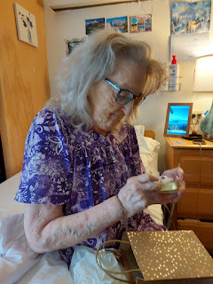

She was already wearing a tanzanite bracelet, so she paired it with the slender silver bracelet that I gave her . . .

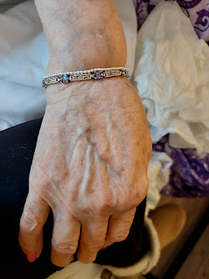

We visited and laughed and got caught up on all the happenings between her large family and mine. We ordered some lunch and I went and picked it up and brought it back to her room. We had a lovely visit, even if it was a little short . . .

After school, Gwen excitedly announced that she hoped to finish up this giant math workbook by the end of Christmas vacation . . . it was only 366 pages . . . LOL

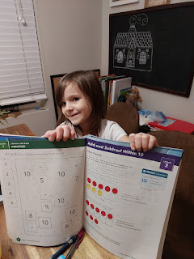

The gift we received that evening for the 8th Day of Christmas was . . .

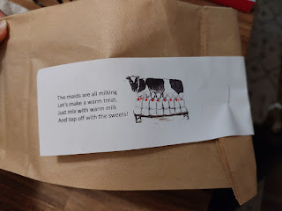

Hot cocoa mix!!

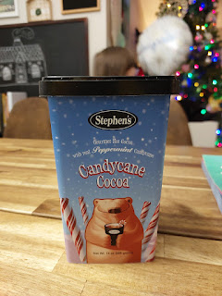

I took the girls over to the Portland Temple after dinner. We brought flashlights and went on an explore all around the temple grounds. It's only 1.5 miles from their apartment complex!! How nice to be so close.

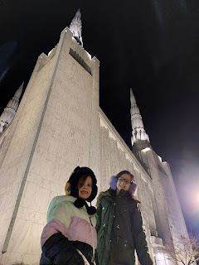

I thought these pink flower petals were so pretty, even if they had fallen down onto the ground . . .

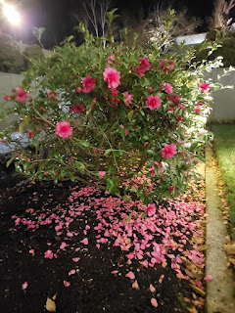

The Nativity scene in the water feature, along with the lights and the reflection of the temple was breathtakingly beautiful . . .

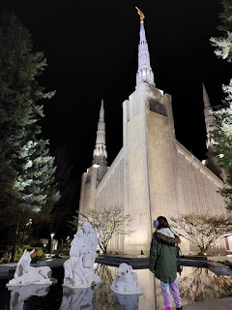

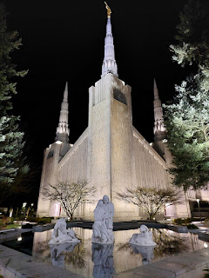

Abby and Gwen wanted to do some dancing on the small wall next to the water, so I recorded each of them and made it into a video reel on Instagram and Facebook. It turned out so beautiful as I added the song, "Angels We Have Heard On High" in the background while they danced in front of the temple.

Abby's dance: (9 seconds)

https://photos.app.goo.gl/Be4kAboNYeSs6yFF6

Gwen's dance: (I chose a different and shorter version than this for my reel) (14 seconds)

https://photos.app.goo.gl/S3Gbu37xKP2w7VJA6

We had a wonderful time at the temple and chatted the whole way home about how Abby will be able to go inside the temple soon when she turns 11, and what she can expect it to be like. She asked a lot of good questions. :)

A little more slime time before bed . . . ha ha

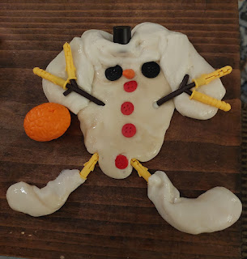

Saturday, December 21st:

I spoke to Scott earlier than usual (with the now 9-hour time difference). He was at the church in Vicenza to set up the font for a baptism later that afternoon. He called because he wanted to show the girls how he set it up during our video call. They kept saying, "That's sooo cool!"

I shared the details about the setting up of a font in a previous blog - maybe a year or two ago, but it goes something like this: He has to spread out a waterproof mat on the floor of the Relief Society room, then build the wooden panels of the oval-shaped font by fitting them together. Next, he secures a blue waterproof liner on the inside of the font, and attaches a long hose from the kitchen next door to fill it up. There's a nice long trail of slip-resistant rug thingies so the person getting baptized can safely walk to the bathroom across the hallway to change into dry clothes afterwards. After the baptism, he then drains the font by running the aforementioned hose out the window and down to the parking lot below (behind the building) where there is a good-sized drain in the ground. Lastly, take it all apart and put everything away, and then voila. Completo.

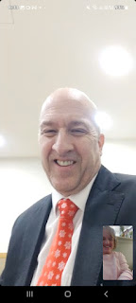

I then took the girls out to breakfast at the newly opened IHOP restaurant in Lake Oswego. It was cold and rainy that morning, so the girls wanted some hot cocoa. We had a great time working on word search puzzles on their placemats while we waited for our food. Gwen ordered sprinkle pancakes with whipped cream, scrambled eggs and two sausages. She snarfed up the sausages first thing, and then the whipped cream, ha ha.

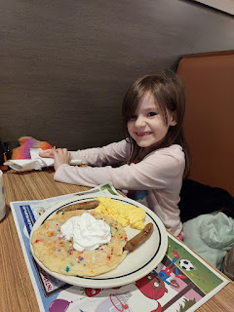

Abby, on the other hand, ordered a cheeseburger and fries off the kids menu. She was just as happy as Gwen was with her order.

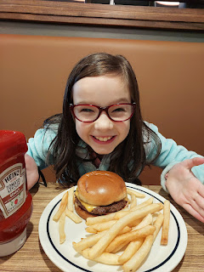

I ordered an omelet with double blueberry pancakes on the side. I had a lot of leftovers to take home because even when I have a large appetite, I still only have a smallish stomach . . .

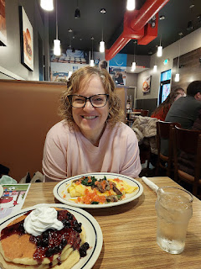

Amber and Weston had a wonderful time down in Florence. They met up with a colleague of Weston's (through his optometry job) who took them foraging for wild mushrooms. They found some beautiful chanterelle mushrooms (bright orange) that they brought home to dehydrate. They also walked along the beach and had some fancy food each day. They said it was really relaxing and fun.

That evening, we received the 9th Day of Christmas gift and poem . . .

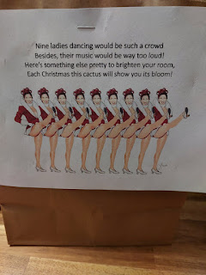

A Christmas Cactus plant . . . XOXO

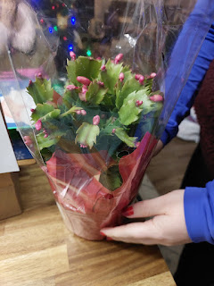

Lake Oswego hosts a Christmas boat parade of lights each year and we were able to be a part of it. This link shows the route of the boats as it comes down the Willamette River from Portland to Lake Oswego:

https://www.christmasships.org/schedule/columbia-river/8-lake-oswego-combined/2024-12-21-16-30

We drove over to the George Rogers Park, about a 15 minute drive from their apartment. I dropped them off while I found a place to park. I'm glad I did that because the boats were already passing by! I hustled over as fast as I could after I parked a few blocks away, and got to see the very last ones. Amber said there were some HUGE yachts before the smaller ones came by at the end. What a cool idea to share with the families of the Portland area for the holidays.

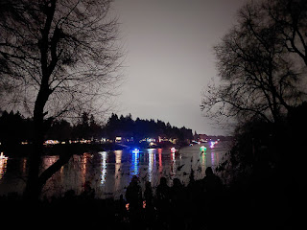

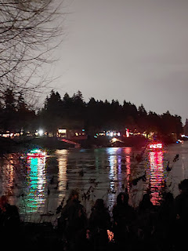

Video of the parade: (11 seconds)

https://photos.app.goo.gl/WXdTT2x7ay3jqzAU7

There was even a boat made to look like a fire truck, and they played a siren, too: (7 seconds)

https://photos.app.goo.gl/uPkCKbBtnSoAy9hW9

Sunday, December 22nd:

We went to church and wow, was the music spectacular! The choir director was clearly a professional who took her job very seriously. Amber did a fabulous job in her section and we could hear her voice above everyone else's a few times. She has a really pretty voice, with a huge range, too. She can sing down in the bass section or clear up at the tippy top of the soprano section.

After Sacrament meeting, they had a "Linger Longer" in the Primary room with a variety of desserts and a hot cocoa bar set up.

We just relaxed for the rest of the day and hung out at home.

Monday, December 23rd:

We switched out the shelf units that I had bought for the two pantry closets with a taller shelf unit that Amber and Abby put together. We transferred everything over to the new shelf unit and I ended up bringing the other two smaller ones home to Idaho Falls. My niece, Mari, has one of them, and soon I will set up the other one down in my craft room.

We did some last minute Christmas shopping at Walmart, where I took Gwen around the store in my cart so she could find a few items for the other family members. Amber took Abby in a separate cart to get a few things. I also bought some chains for my car, just in case I might need them on my drive home to Idaho after Christmas.

After lunch, we drove down to Salem again so that Amber and the girls could visit Grandma Lillian. Grandma had just wrapped up a visit with her granddaughter - and my cousin - Christina (I grew up calling her Christy all these years, but she decided she wants to be called Christina now). Christina's husband, Travis, their son Conner, and daughter Skyler were all there, too. By the time they left, Grandma's back was starting to act up and she had to lay down to rest on her heating pad.

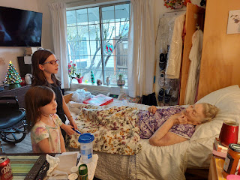

We visited for a while and then we sang her some Christmas carols. We started off singing Jingle Bells, with the girls adding in their new kazoos for the chorus. (That was the 10th Day of Christmas gift from the night before.)

Jingle Bells: (34 seconds)

https://photos.app.goo.gl/11QTFR8xkyvWsr8Y9

12 Days of Christmas (just the last verse): (34 seconds)

https://photos.app.goo.gl/Kogs2P5Y1ehrY21L9

A snippet of a song called Winter Walk that the girls learned at school: (9 seconds) (It's kinda long so I just recorded a tiny bit)

https://photos.app.goo.gl/iiW6jMARKgLNpahS8

When we asked Grandma what her favorite Christmas song was, she surprised me by saying, "Edelweiss" - from the Sound of Music. Amber knew all the words, so I just let her sing it solo.

Edelweiss: (50 seconds)

https://photos.app.goo.gl/VGWg7MPU76frpE8j8

The girls loved figuring out how to navigate in Grandma's wheelchair: (5 seconds)

https://photos.app.goo.gl/ZGRiPciKwdY3yjbGA

When Grandma offered some snacks to the girls, the fig newtons reminded Amber of a song they used to sing in her physics class in high school. If they performed this song in class, they'd get extra credit!

Fig Newton song: (16 seconds)

https://photos.app.goo.gl/Ear6JU6oQddWbMQy9

Abby offered to scratch Grandma's back and I thought it was so sweet: (5 seconds)

https://photos.app.goo.gl/xiwQpUiicuuSxVKSA

We only stayed a little over an hour, because we could tell that Grandma was a little tired. She had had two family visits back to back, and she probably needed some rest. We gave lots of hugs before we left.

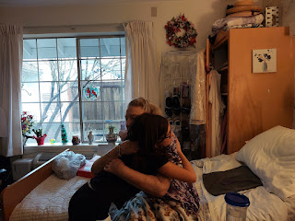

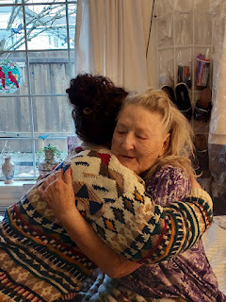

We stopped outside at the newly renovated duck pond before we headed back home. The girls didn't have any duck food this time, but they tried to coax the husband/wife duo to come closer to them.

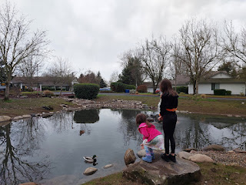

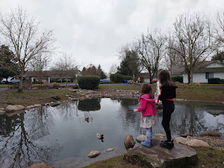

Tuesday, December 24th:

I tried to help a little here and there, with errands or with wrapping gifts, but mostly everything fell on Amber and Weston's shoulders. I hung out with the girls, too, but gosh I was pretty tired myself . . . Whenever Amber suggested that we watch a Christmas movie, I was relieved because that meant I could relax and just veg out for a while. I always tried to quietly fill in with things like washing the girls' laundry and then helping them fold and put it all away, or I'd wash the dishes that didn't fit into the dishwasher, or I'd break down the cardboard from all the Amazon boxes piled ceiling-high and then the girls and I would load them into their wagon and hike across the apartment complex to the recycling center to dump them.

I picked up these two darling poinsettia plants from Trader Joe's so that I could place them on a couple of important family graves on Christmas day. They sat happily in the kitchen windowsill while they waited for our upcoming adventure.

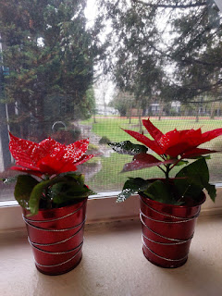

Gwen wrapped up their cat, Broski, into a soft blanket and then handed him to me to snuggle. I have a mild allergy to cats, so I try not to actually pet them very often. If I do, then I need to wash my hands right away, so I don't accidentally rub my eyes or I'll be sorry . . . Broski is a cuddler and he didn't mind one little bit being wrapped up like a giant burrito. Gwen offered to take a photo of us, and while the other photos turned out a little blurry, the one that

did

turn out was right when I thought she was done and I was reaching for my phone, ha ha.

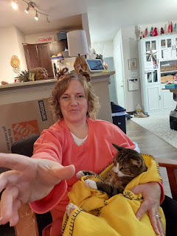

I helped Amber clean up the living room, dining room and kitchen before bed that night. They have so much stuff, because after all they're a FAMILY and families have lots of stuff. It's hard, though, when you've moved from a house down to an apartment. But space was needed for Santa to come and for gifts to be opened in the morning, so we cleaned and tidied everything up.

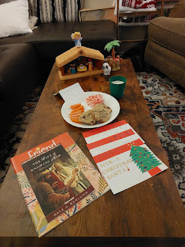

Abby orchestrated a family note to Santa Claus, and cookies and milk were set out for him to enjoy, as well as some carrots for his reindeer. All was finally quiet in the house on Christmas Eve.

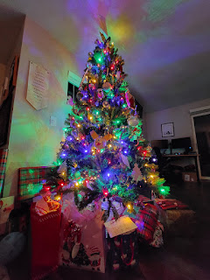

Santa came after the girls were fast asleep . . .

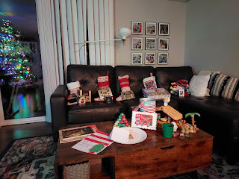

Abby woke me up at 2:00 a.m. because she was too excited to sleep. She wanted to go out to the living room to peek, and I told her it was okay as long as she was quick and didn't touch anything. She came back even more excited and then she couldn't go back to sleep until around 4:00 a.m. Since we share a bedroom, that meant I couldn't sleep either . . . she had already had some melatonin before bed, so I put some relaxing essential oils on her feet and that seemed to do the trick. I didn't get much sleep that night because there were some teenage boys partying it up in the apartment above ours, so I had only fallen asleep around 12:30 a.m. when Abby woke me up at 2:00. And then everyone woke up by 8 a.m. and that was that. Oh, the magic of Christmas . . .

Wednesday, December 25th:

Everyone was happy with all of their gifts and a nice spirit permeated their home. Amber and Weston bought me a Kindle so I can have some books to read when I travel back and forth to Italy, without having to haul a heavy book in my backpack. I'm excited to load a few books onto it soon. My stocking was loaded to the brim with various chocolates. Enough to last me until next Halloween probably . . . Santa knows me well, and that I do love chocolate . . .

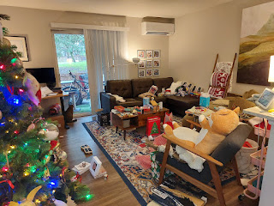

Mid-afternoon, we paused watching Miracle on 34th Street (the 1994 version - SO CUTE) so that I could go to the Willamette National Cemetery with Abby. It was rainy and cold outside, so Gwen opted to stay home, but Abby is always wanting to be a part of any adventure, so she came with me and I'm so glad she did!

We researched online before we went so that we could find my Grandpa Linton's headstone in the vast cemetery, plus my Uncle Mark's headstone. We combined using Find-a-Grave and also the military cemetery website to double check the sections and the headstone numbers.

Google Maps took us to the entrance of the cemetery, but the online map of the cemetery was the most helpful. I used a screenshot that I had saved to help us once we got inside the entrance. Abby is super helpful in navigating, and together we found right where we needed to be.



My Grandpa Linton's headstone . . . (my mom's father)

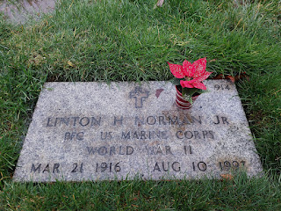

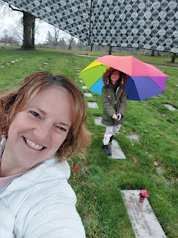

Abby and me, with our trusty umbrellas in the rain . . .

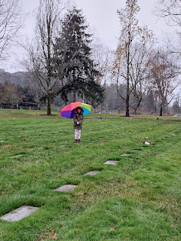

There were several geese slowly waddling along through the cemetery a short distance away . . .

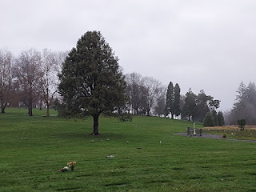

I don't know how we managed to keep our boots as clean as we did. It was the soggiest and squishiest cemetery I've ever been in. With each step, you'd sink down and you could hear the slurping as you lifted your foot up to move forward. We ended up cheating a little and used some of the level headstones as stepping stones . . . we figured they wouldn't mind too much - just this once.

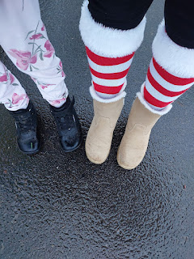

My Uncle Mark Moore is the youngest son of Grandma Lillian, from her first marriage to Dean Moore. She had five sons: Mike, Dave, Gary, Tim, and Mark. I asked Benson what the AB stands for on this headstone, and he said it means "Airman Basic". Sort of like a Private in the US Army.

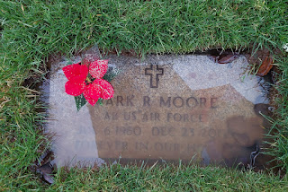

The fog was so pretty on Christmas Day. As I stood at Grandpa's grave for an extra little bit, while Abby began slowly picking her way back to the car through the swampy grass, I felt a little surge of joy from him. I knew he was happy that I had come to visit at his final resting place, and that I had brought his great-great granddaughter with me, too. It felt so good in my heart and I was warmed to the brim.

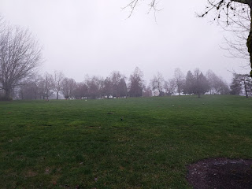

Abby commented several times the rest of the day how much she loved going there with me. That tells me that it meant a lot to her, too. We are looking forward to going again someday - in better weather when it's not so soggy!

Video of the cemetery - and Abby being silly as she said "Geeth" over and over, her goofy version of Geese: (17 seconds)

https://photos.app.goo.gl/ethjZeNrRN8UGsVL6

Merry Belated Christmas to all of you who read my blog. All 12 of you, ha ha. I hope you felt the true spirit of the season, in whose birth we celebrate, even Jesus Christ. Our Savior and Redeemer and Light of the World.